**soloLearn 19.2 Practice Pro** 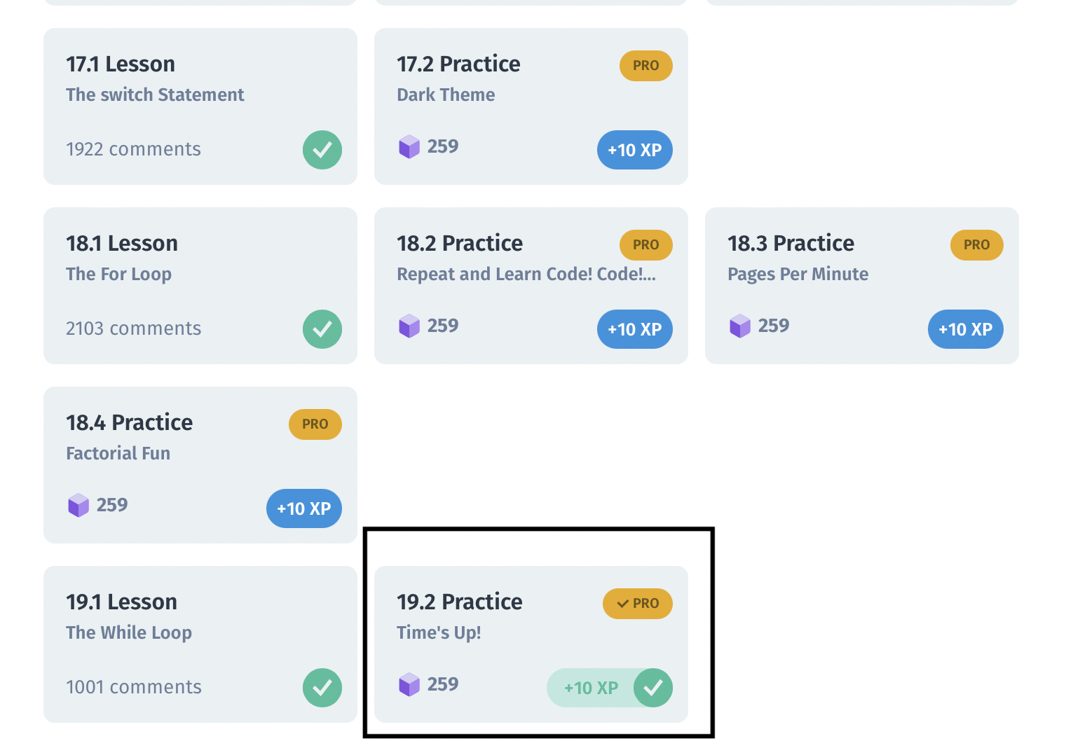

**Problem:**

Input: 4

Output: 4

3

2

1

0

**Solution:**

Here the problem is required to print all decremented integers till 0 from given input.

We need to print an output to console repetitively, therefore use of for loop become obvious,

for (i=input; i<=0; i–) {

console.log(i)

}